Basic Training Plan outline for TURAS monitoring

Doc-25 (v3)

Trainee full name: |  |  | Trainee email (professional):
Name of Training Programme and/or Qualification/ Specialism/ Method of Registration  (as appropriate) |  |  | Name and Address of Main Training Department:
Date this training commenced: |  |  |  |  | Plan’s anticipated completion date:
Lead NHS supervisor / training programme director: |  |  |  | Lead NHS supervisor email:
Date of this plan:

Outline plan: specify main elements, rotations, placement and principal NHS supervisors for each. Insert / delete rows as required. Examples are below.

 | Activity | NHS Location | From | To | Duration | Activity supervisor (NHS): | Activity supervisor (NHS) email
Year 1

Year 1

Year 1

Year 1

Year 2

Year 2

Year 2

Year 2

Year 3

Year 3

Year 3

Year 3

Guide:

Example 1: a postgraduate scientist trainee undertaking an MSc part-time (employed in pathology as a biomedical scientist)

Example 2: a postgraduate scientist trainee on a structured training programme (employed as pre-reg clinical scientist)

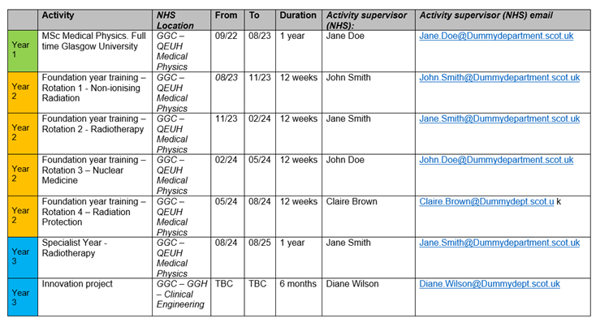

Example 3: a postgraduate scientist trainee not on a specific training scheme but acquiring competences to meet a specific standard (employed as a respiratory physiologist). Plan is incomplete but at least sketches out Year 1.

